Cyber Crime and Security
In this paper author is describing about various attacks such as phishing, Denial of Service (DOS), Botnets, Malware and many more and describing technique to avoid such attacks by installing antivirus and firewalls. As we know not all antivirus are capable of prevents all attacks and similarly we also cannot built a tool which can prevent all describe attacks. So in this paper we are trying to simulate and prevent DOS attacks where attacker will send huge amount of request to server and server will get busy in processing such huge request data and get crashed and services to normal users will be denied. To overcome from such issue we can attach a network packet monitor to server which will inspect all incoming request and if request size is in server processing limit then it will forward request to server otherwise monitor will discard request to save server from getting crash and from DOS attack.
To monitor network traffic we have used Bigdata Hadoop MapReduce programming model to evaluate all packets request and then inform to server whether request is normal packet size or attack. MapReduce will read input packets and then check whether request size is in server capacity or not and if request is in server capacity then file will be forward to server for storage else discarded.
To implement this project we have designed 3 modules
- Server module: In this module server will run in infinite loop and wait for client request and if client send any data then it will receive and store it and if client send request to download a file then server will send that file back to client.
- Network Monitor module: This is a MapReduce application which will inspect all incoming packets and then analyse it and if all packets are server capacity limit then it will forward packets to server for storage else discard it.
- User’s module: This is a simulation module where users will send request to server for file upload or download, if any malicious user send huge size of file then network monitor will discard such file from storage at server.
SCREENS
To run project first double click on ‘run.bat’ file from Server folder to start server and to get below screen
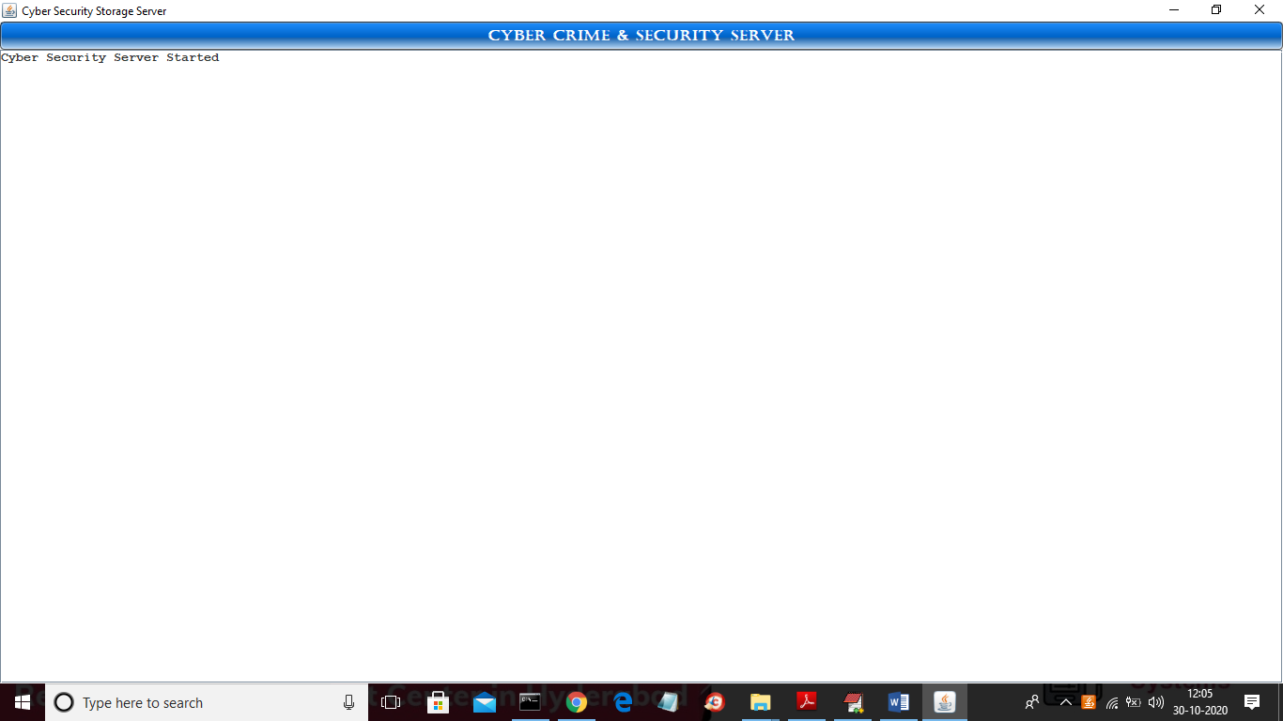
In above screen server started and now double click on ‘run.bat’ file from ‘NetworkMonitor’ folder to start map reduce monitoring
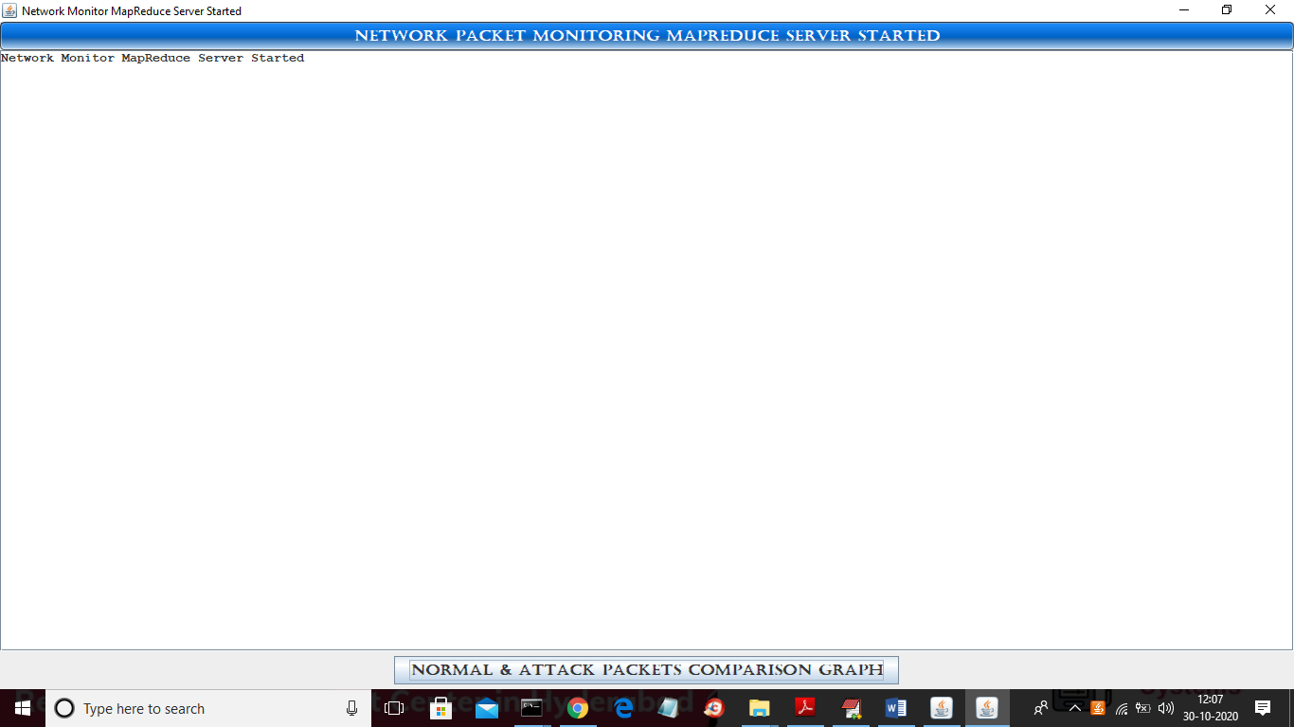
In above screen monitor server also starts and now double click on ‘run.bat’ file from Users folder to get below screen
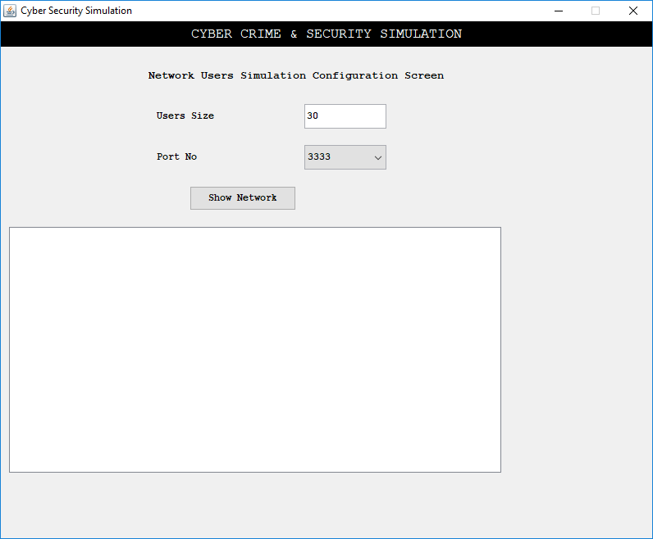
In above screen I entered users size 30 and server port number 3333 and now click on ‘Show Network’ button to get below screen of simulation
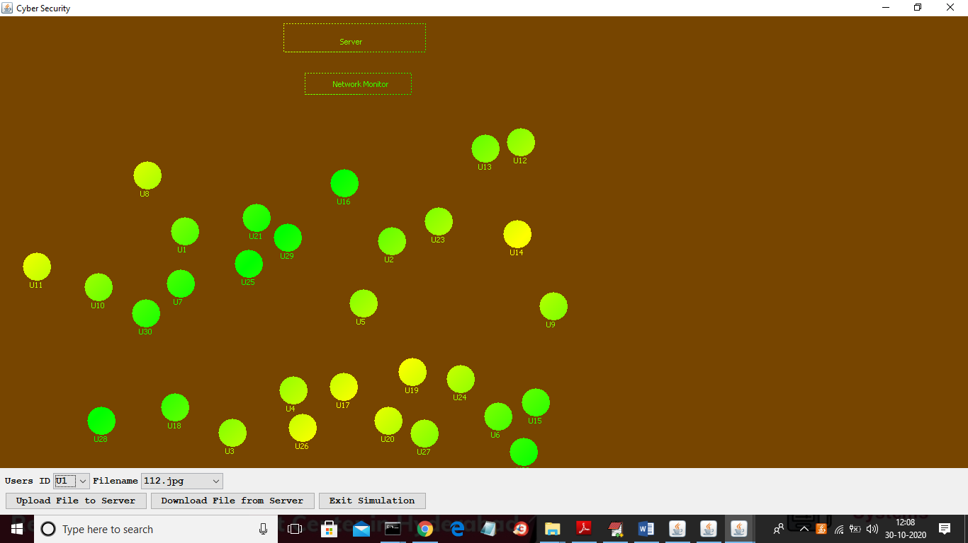
In above screen each circle represents one users and rectangle represents monitor and server and in above screen select any user from dropdown box and then click on ‘Upload File to Server’ button to upload file
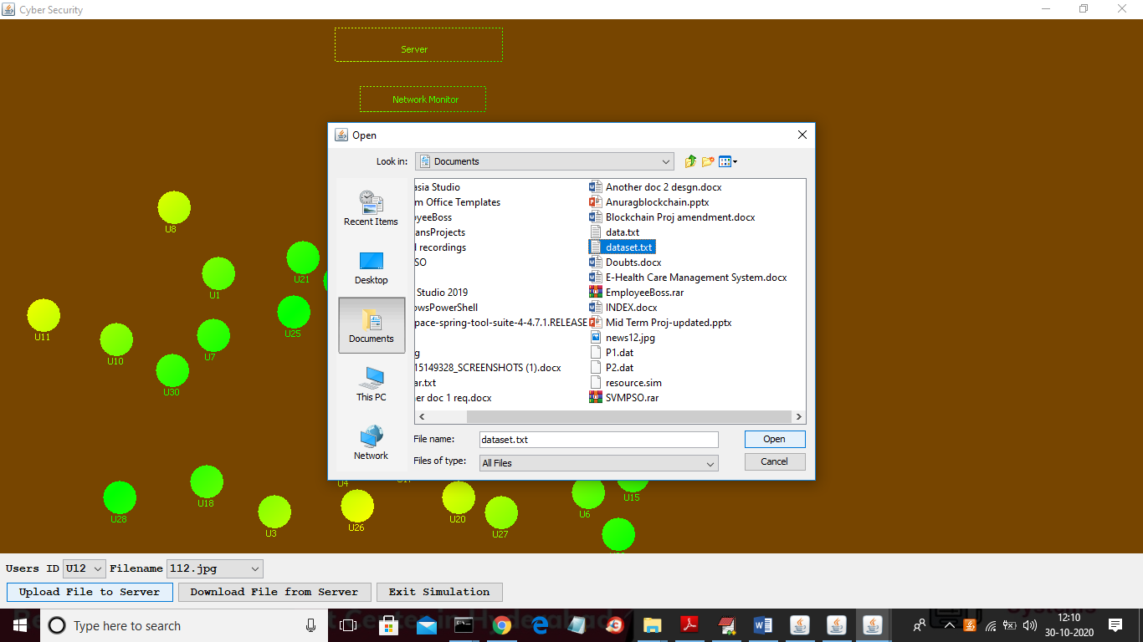
In above screen I selected U12 and then click on upload button and then select file as ‘dataset.txt’ and now click open button to upload file to server
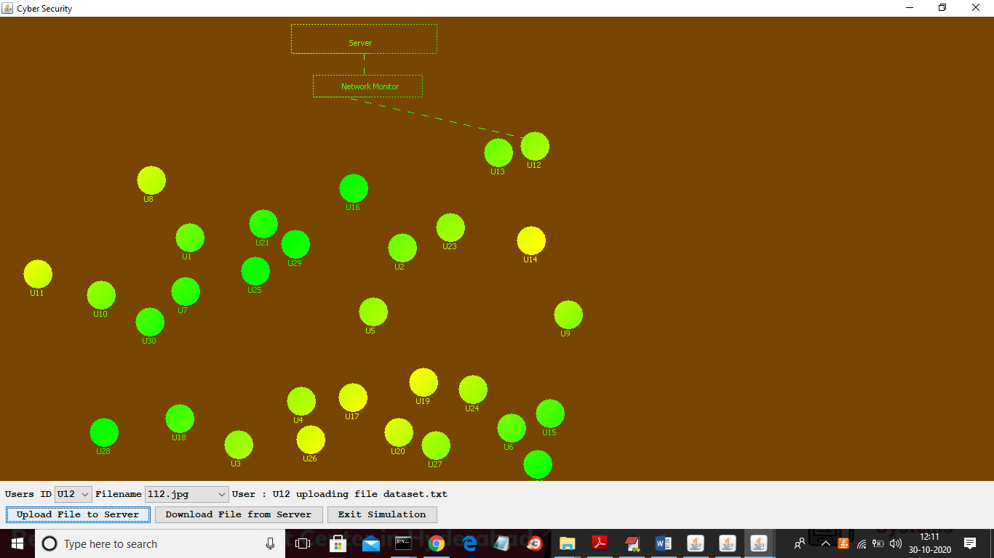
In above screen we can see U12 is sending data to server and its analysing by network monitor and below is the result
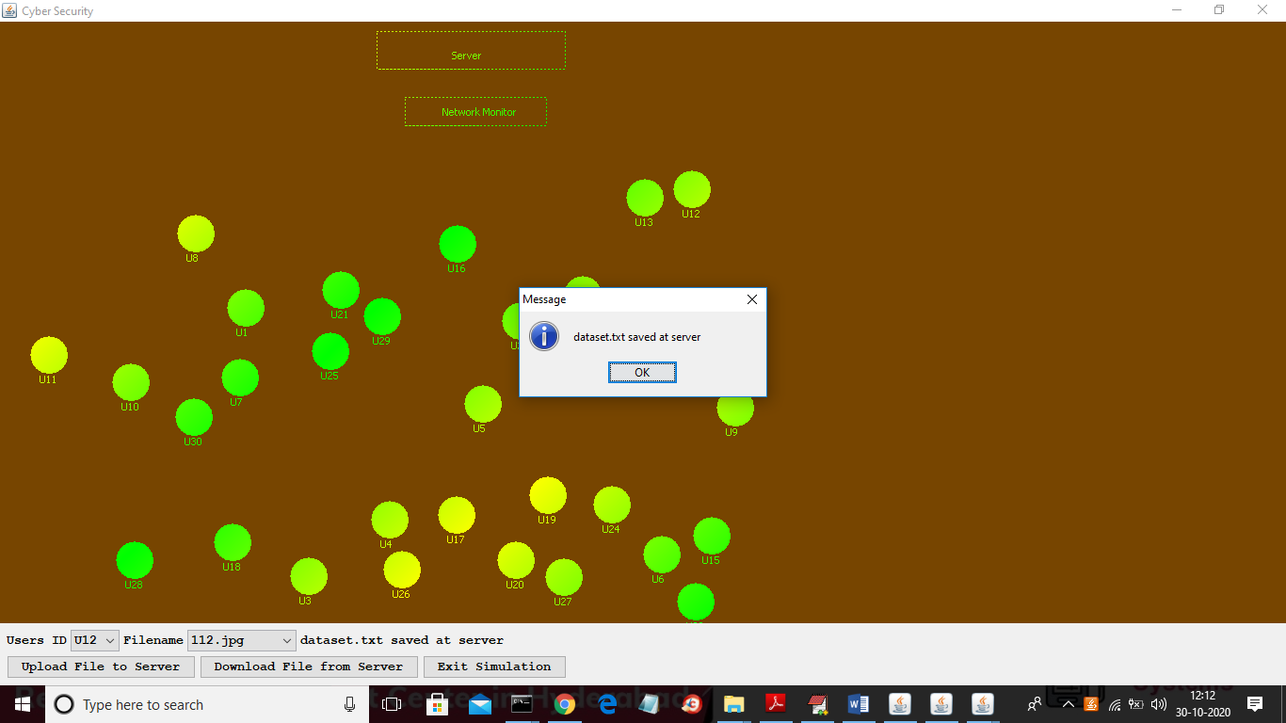
In above screen we can see file is in limit so network monitor allow it saved on server and the uploaded dataset.txt file we can see in drop down box
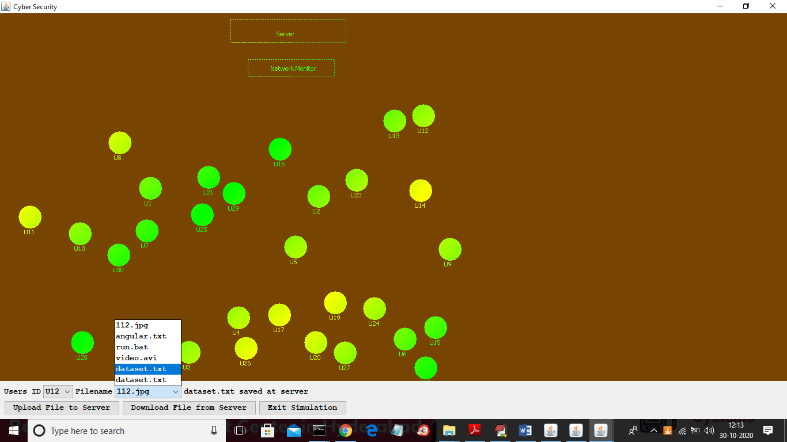
Now in below screen we can see network monitor status
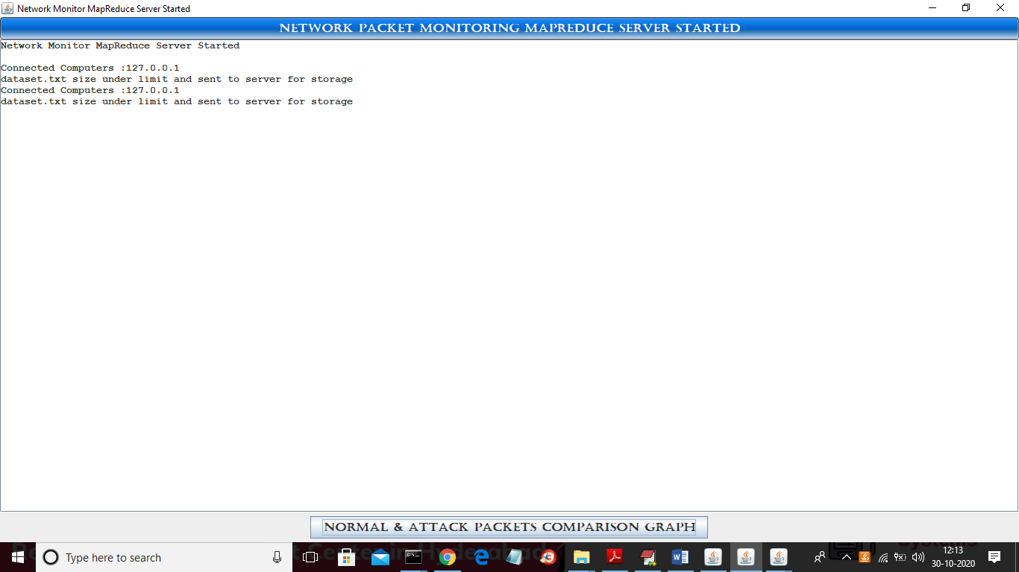
Now in below screen we can map reduce processing at network monitor console
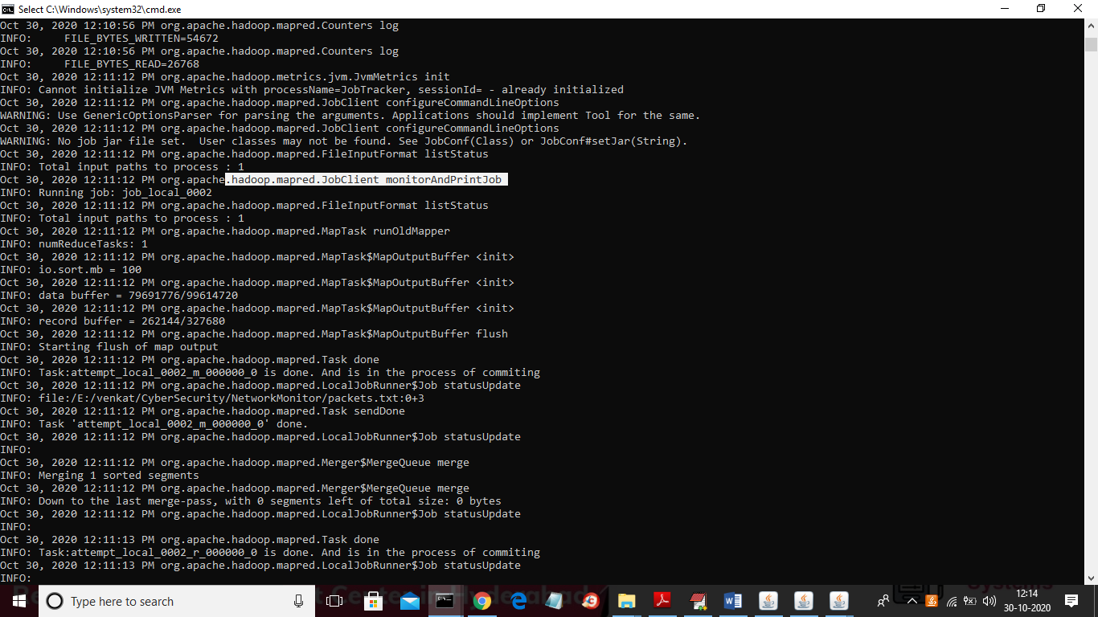
In above screen we can see Hadoop map reduce monitoring job and now we will upload big file and see result
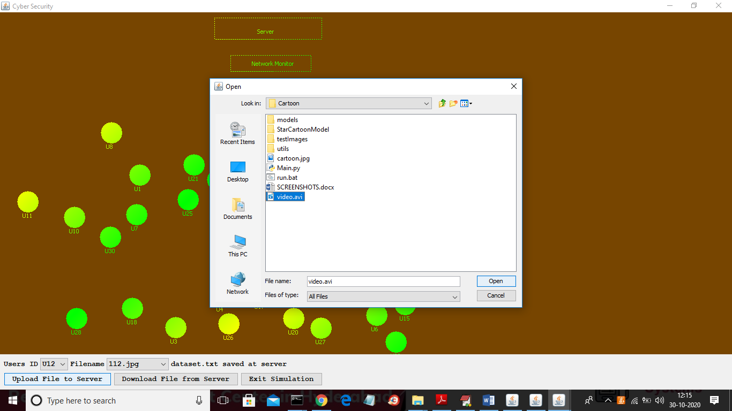
In above screen I am uploading video file and below is the result from network monitor
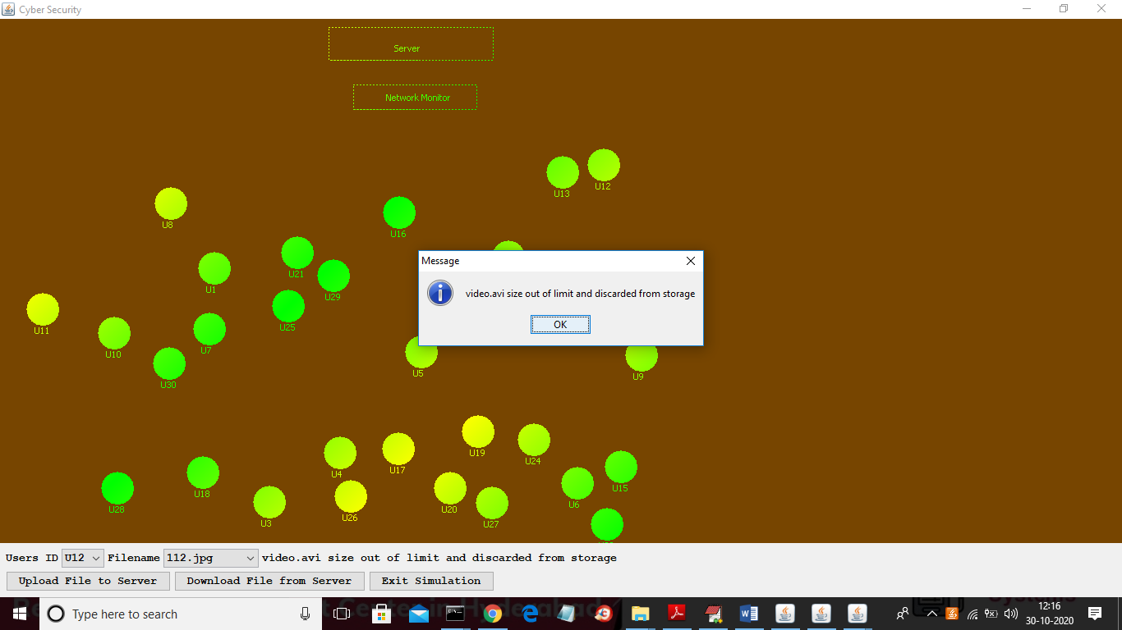
In above screen we can see network monitor discarding video file as its size is out of server limit and now click on ‘Download File From Server’ button by selecting user and file name from drop down box
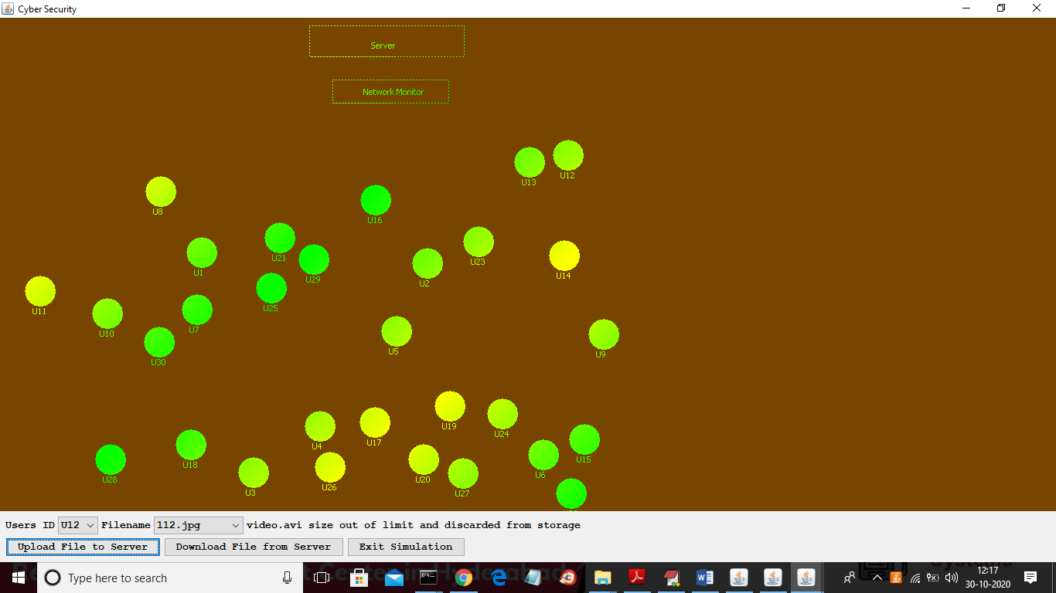
In above screen I selected U12 and 112.jpg file from drop down box and now click on ‘Download File’ button to get below result
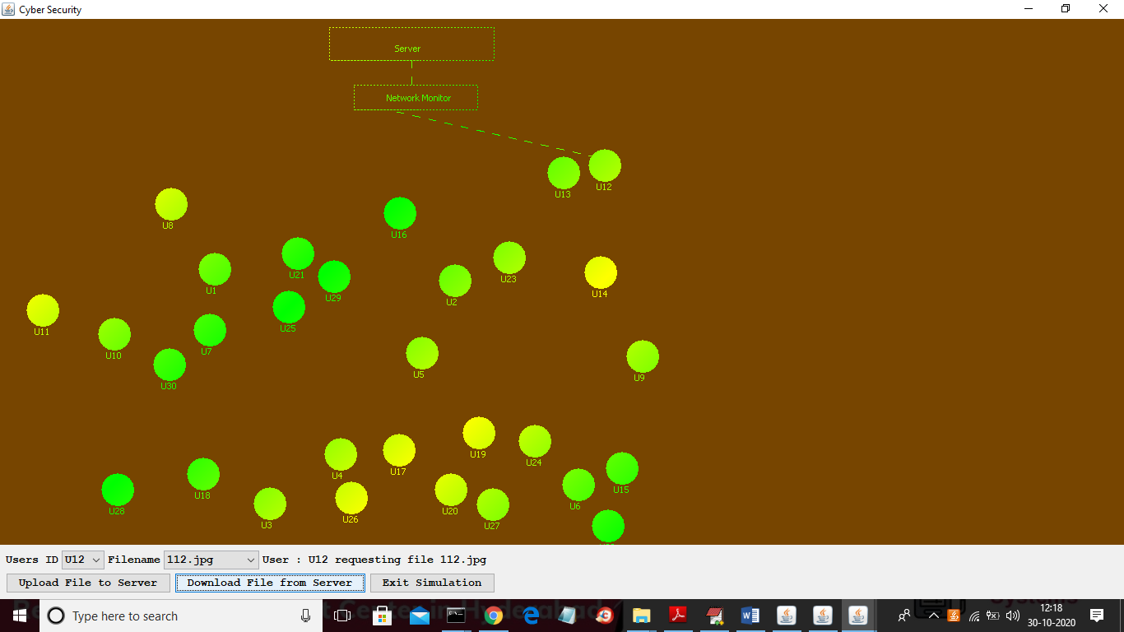
In above screen file is downloading and after download will get below screen
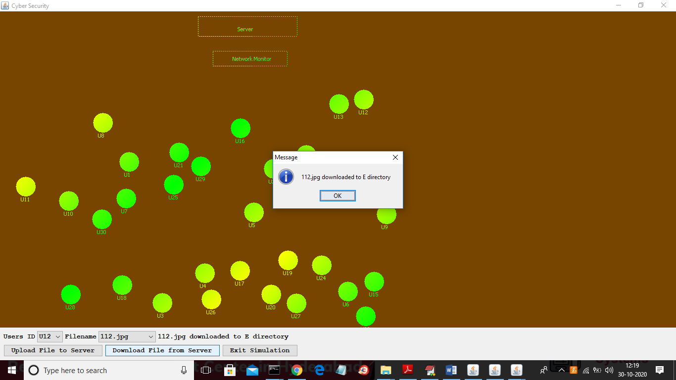
In above screen file is downloaded at E directory and now go to Network Monitor screen and click on button to get below graph
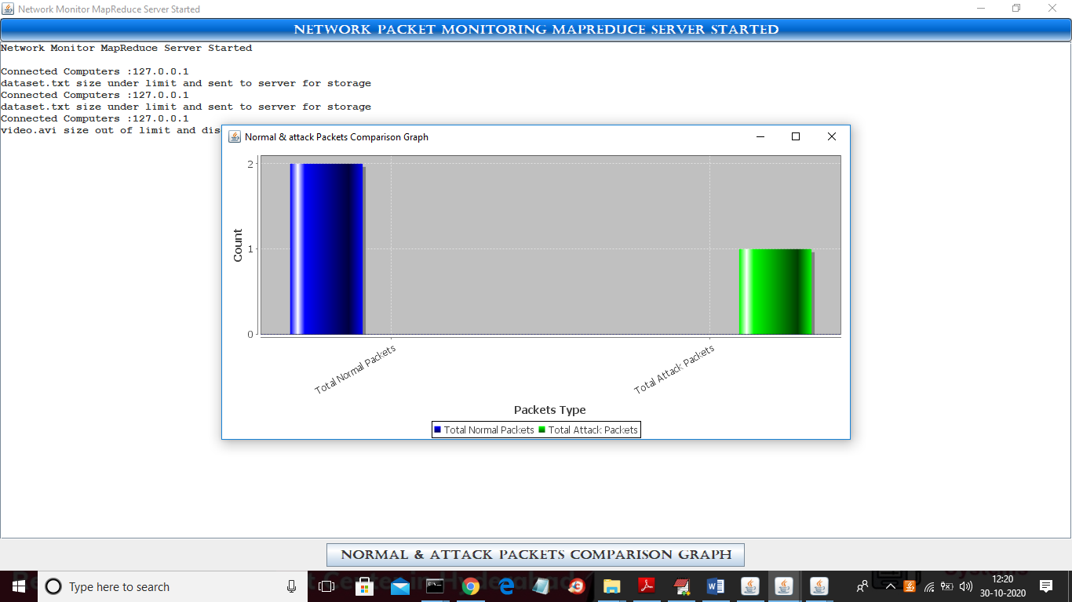
In above normal and attack graph we can see how many request monitor has received and out of that how many are normal and how many are attack request. In above graph x-axis represents packet type and y-axis represents count of those packets.
Below is the server screen of all processed requests
